PFC Freddie J. Keeley
28E 060
Died October 24, 1967
A Troop 3rd Squadron 4th US Cavalry
25th Infantry Division
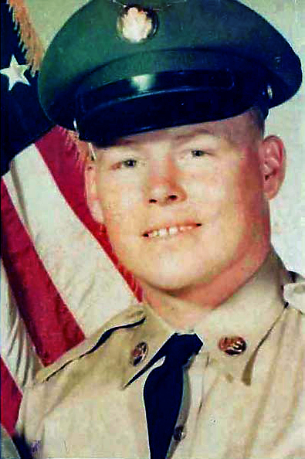
“Here’s to us who fought for it,
The sheltered shall never know
The price or glory of freedom.”
By an anonymous Vietnam Soldier

I served in Vietnam with Freddie

