PFC Gilbert King
47W 029
Died August 22, 1968
A Troop 3rd Squadron 4th US Cavalry
25th Infantry Division
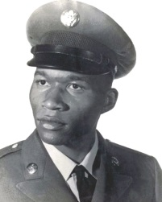
“Here’s to us who fought for it,
The sheltered shall never know
The price or glory of freedom.”
By an anonymous Vietnam Soldier

I served in Vietnam with Gilbert

