SP4 Glen L. Atkinson
33W 046
Died February 3, 1969
D Troop 3rd Squadron 4th US Cavalry
25th Infantry Division
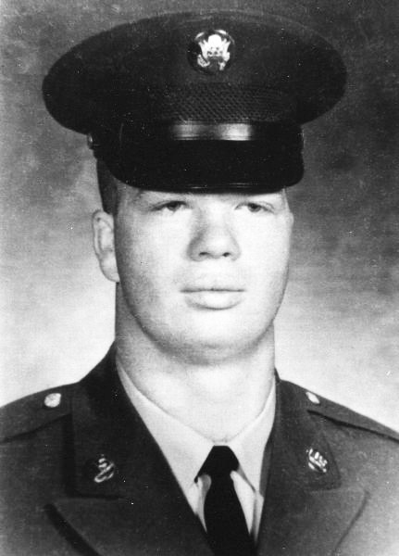
“Here’s to us who fought for it,
The sheltered shall never know
The price or glory of freedom.”
By an anonymous Vietnam Soldier

I served in Vietnam with Glen

