CPL James M. Davis
09W 037
Died June 10, 1970
A Troop 3rd Squadron 4th US Cavalry
25th Infantry Division
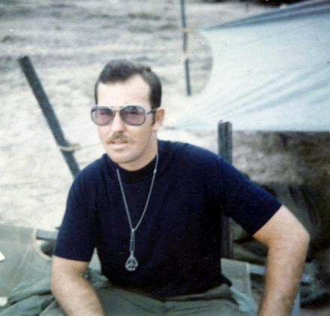
“Here’s to us who fought for it,
The sheltered shall never know
The price or glory of freedom.”
By an anonymous Vietnam Soldier

I served in Vietnam with James

