SP5 John E.Dobash
26W 045
Died February 28, 1969
A & D Troops 3rd Squadron 4th US Cavalry
25th Infantry Division
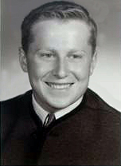
“Here’s to us who fought for it,
The sheltered shall never know
The price or glory of freedom.”
By an anonymous Vietnam Soldier

I served in Vietnam with John

