CPL Randy C. Brackin
07W 029
Died September 1, 1970
A Troop 3rd Squadron 4th US Cavalry
25th Infantry Division
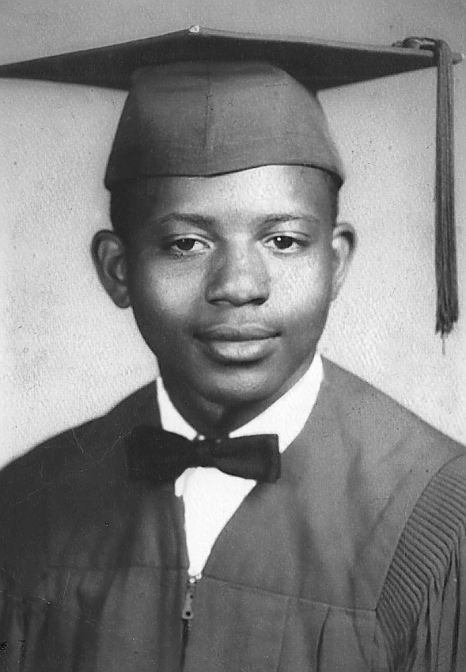
“Here’s to us who fought for it,
The sheltered shall never know
The price or glory of freedom.”
By an anonymous Vietnam Soldier

I served in Vietnam with Randy

